Do Prediction Markets Lead Stock Markets? Evidence from Information Shock
Hongxin Liu and Aria Shi
Abstract:
This project studies whether prediction markets incorporate information faster than equity markets by examining the lead–lag relationship between prediction market probabilities and stock returns. Using nanosecond-level TAQ data, which will be aggregated into lower frequencies, (such as the second and microseconds), we will construct portfolios of stocks that are sensitive to changes in expectations and test whether movements in prediction market odds predict subsequent stock returns, or whether the reverse is true. Understanding which market leads in information discovery can shed light on market efficiency and the role of expectations in asset pricing. The project will combine event analysis, time-series methods, and portfolio construction to provide empirical evidence on how information is transmitted across markets.
Research Question:
Lead–Lag Dynamics Between Prediction Markets and Equity Markets
Significance:
This research helps answer a simple but important question: when news breaks, which market “figures it out” first? Financial markets are often viewed as mechanisms that aggregate information about the future. Political, economic and technical developments can have substantial economic consequences, such as elections, recessions, and boost of AI. And investors continuously update their beliefs about these outcomes. Prediction markets provide real-time measures of collective expectations, while stock markets reflect investors’ responses to anticipated economic impacts. Understanding which market incorporates information more quickly is important for evaluating market efficiency, understanding how expectations are formed, and assessing whether prediction markets provide incremental information beyond traditional financial indicators.
Project Design (Methodology):
1. Focusing on major events in the “political,” “companies,” “financial,” and “tech & science” categories, which constitute the primary domains where expectation updates are likely to have measurable effects on financial markets. In addition, news reports from major media outlets will be gathered to establish precise event timelines and to account for the role of public information releases in driving both prediction market probabilities and stock price movements.
2. Portfolio Construction: To avoid look-ahead bias and circularity, we construct portfolios using pre-defined market and sector indices within the S&P 500 rather than selecting individual stocks based on realized returns. Sector indices such as technology, financials, and energy serve as proxies for groups of firms likely to be affected by political and macroeconomic developments reflected in prediction market prices. These portfolios are fixed ex ante and remain unchanged throughout the analysis. Using lower frequency TAQ data, we examine whether changes in prediction market probabilities lead or lag portfolio returns, allowing us to study information transmission between prediction markets and equity markets without relying on ex post stock selection.
3. Lead–Lag Analysis: Use time-series techniques such as cross-correlation, vector autoregressions, and Granger causality tests to examine whether changes in prediction market probabilities precede stock returns.
4. Robustness Checks: Examine overnight returns and alternative portfolio definitions to test whether results are consistent.
Feasibility:
Prediction market data will be obtained from publicly available shared datasets on GitHub, which provide historical prices for prediction contracts for a wide range of events, which will be interpreted as market-implied probabilities. High-frequency stock market data will be accessed through databases subscribed to by NYU, ensuring reliable and comprehensive coverage for our empirical analysis. In addition, since TAQ data, which will be provided at microsecond frequency, requires WRDS access, we plan to consult with the NYU librarian, Henry Huang, to explore additional data sources and ensure that we are using the most appropriate and complete datasets available for this project. Dataset on Kalshi, the prediction market data, will also be provided at microsecond frequency. News articles will be collected from major public news outlets, including large international and national media organizations, to document how events are reported and to help identify the timing and context of information releases relevant to our analysis.
Week-by-Week Timeline:
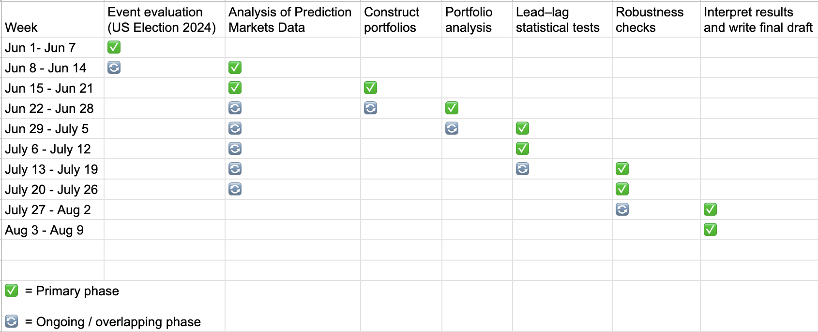
Budget:
No additional expenses anticipated beyond computing resources already available. The project will not require travel or proprietary data purchases.
Background:
Both of our two members in our research group have completed coursework in economics, statistics, and basic data science courses that have prepared us to analyze financial data and conduct empirical research. Both of us have done basic Python programming training, and finished coursework related to economic modeling and data analysis. These experiences have equipped us with the technical skills needed to collect data, perform statistical analysis, and interpret results in a research setting.
Group Partnership Plan:
Our group consists of two members: Aria Shi and Hongxin Liu. We will divide responsibilities for collecting news, stock market, and prediction market data across different sections of the project. Codes and the draft will be uploaded to github to facilitate collaborative modeling and analysis, and data will be shared through Google Drive even while we are in different locations. The final paper will also be drafted in a shared document, with each member taking primary responsibility for writing their respective sections. Aria Shi is majoring in Data Science, while Hongxin Liu is double majoring in Business and Finance and Data Science. Our complementary academic backgrounds enable us to integrate quantitative modeling with financial and economic analysis, strengthening both the methodological rigor and the practical relevance of our research.
Feedback and Evaluation
We will receive feedback from our faculty mentor: Professor Geoffery Zheng, through regular meetings.
Dissemination of Knowledge
The results will be presented at the Undergraduate Research Symposium. We also plan to prepare a written research paper summarizing the findings, methodology, and implications, which could serve as a foundation for future academic work.
Reference
Becker, Jonathan, and Piotr Rybiec. (2026). prediction-market-analysis: Prediction market data and analysis framework. GitHub repository. https://github.com/jon-becker/prediction-market-analysis

